**Guidelines for the Issuance of Philippine World War II Medals**

(Revision – December 2017)

**Authority:** Armed Forces of the Philippines Regulations G 131-053 dated July 1, 1986

**Processing Time:** Three (3) to Four (4) Weeks upon receipt of request

**Medal/Badge:** (1) Philippine Liberation Medal

(2) Philippine Independence Medal

(3) Philippine Defense Medal

(4) Asiatic-Pacific Campaign Medal

(5) World War II Victory Medal

(6) Philippine Military Civic Action Medal

(7) Philippine Presidential Unit Citation Badge

**Ribbon:** Lapel Ribbon for each Medal is included

**Certificate:** Government Certificate is included

**Issuance:** Please refer to attached criteria.

**Admin Fee:** Ten US Dollars - US $ 10.00 for each MEDAL

Five US Dollars - US $ 5.00 for each BADGE

**Requirements:** 1. Letter Request from the Veteran or next of kin with their complete name, mailing address, and preferably phone number/email address

2. Copy of Service Discharge Document/Other service records showing eligibility and/or Entitlement for these awards.

1. Payment of Administration Fee payable to the **OFFICE OF VETERANS AFFAIRS a**nd write **PHILIPPINE MEDALS** in the **MEMO.**
2. Mail request to:

OFFICE OF VETERANS AFFAIRS

ATTN: Philippine Medals

1600 MASSACHUSETTS AVE NW

WASHINGTON DC 20036

**PHILIPPINE LIBERATION MEDAL**

For participation in the Liberation of the Philippines from Oct 17, 1944 to Sept 3, 1945.



PHILIPPINE DEFENSE MEDAL

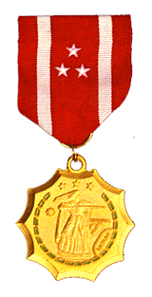For combat service in the defense of the Philippines from Dec 8, 1941 to Jun 15, 1942. The service member is awarded one medal for meeting either of the criteria below. A bronze star is worn if the service member meets both criteria. a) was a member of the Bataan or Manila Bay Forces or of a unit, ship, or airplane under enemy attack during the above period (b) was assigned or stationed in the Philippine territories or waters for at least 30 calendar days during the above period

PHILIPPINE INDEPENDENCE MEDAL

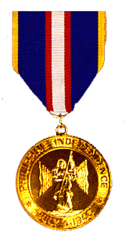For those who received both the Philippine Defense Medal and Philippine Liberation Medal or who were present on duty in the Philippines on July 4, 1946.

WORLD WAR II VICTORY MEDAL

For active duty service at any time between December 7, 1941 and December 31, 1946.

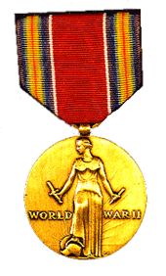

ASIATIC PACIFIC CAMPAIGN MEDAL

For 30 days of service in the Asiatic-Pacific Theater between December 7, 1941 and March 2, 1946.

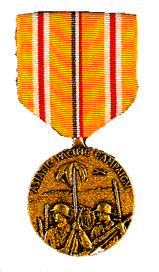

**PHILIPPINE PRESIDENTIAL UNIT CITATION BADGE**

For certain units of the US Armed Forces which participated in the war against the Japanese Empire during the periods 7 Dec 1941 and 10 May 1942 and 17 October 1944 to 4 July 1945.

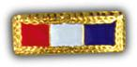

**PHILIPPINE MILITARY CIVIC ACTION MEDAL**

The decoration is awarded to military and civilian personnel of the [Armed Forces of the Philippines](http://en.wikipedia.org/wiki/Armed_Forces_of_the_Philippines) (AFP) and friendly foreign nations by the Chief of Staff, AFP, Commanders of Major Services, Area Commands, AFPWSSUs, Divisions/Brigades or their equivalent in the PAF and in the PN. The award is intended to recognize meritorious achievement in the field of civic action in duty, responsibility or in direct support to military operations.

